Kid’s Palace Nursery School
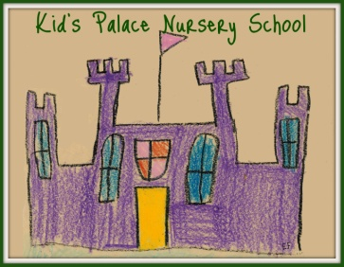
Tour Registration Form

Registration Information
Expected 1st day of care | Registration fee | First payment (includes deposit)
Program Information ft pt
Room | Estimated arrival | Estimated departure | Scheduled days
Registration fee paid with application package: cash or cheque
Tuition fees must be paid weekly by 6pm Friday for the following week
Child’s first and last name | Date of birth mth/day/year
Address | City, postal code
Name of Parent/Guardian | Contact number
Name of Parent/Guardian | Contact number
Contact Email address

________________________________________ ______________________________
Parent/Guardian Signature Kid’s Palace Administration Signature
____________________ _________________
Date Date
This does not guarantee spot. Deposit and 1st week payment secures spot.

